Millat Asian Housing Association

Annual Complaints Performance and Service Improvement Report
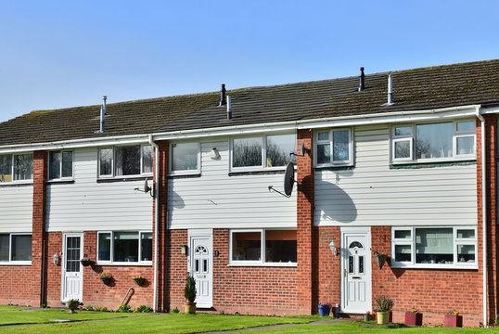
2024
Review and approved by
the Board on: 1st October 2025

Introduction

Millat is a small community-based Housing Association making significant contribution
by focusing on specific housing needs. At Millat, our objective is to support people who need a home in the boroughs of Merton, Sutton and the Royal Borough of Kingston Upon Thames.

We welcome the introduction of the Housing Ombudsman’s code for complaints and welcome feedback from residents and service users.

The report highlights that our levels of complaints are healthy and importantly we manage them as per Code, with the majority being resolved at Stage 1and none have escalated to the Ombudsman.

This report has been produced to meet the requirements of the Complaint Handling Code
whereby residents can explore our service.

Complaints Handling

We have a two-stage complaint handling process, and this is explained in detail in our complaints policy on our website.

All new complaints are investigated at stage one, and a response will be sent within 10 working days from a member of staff involved in the initial problem.

In the event a resident is unhappy with our stage one response or believes we haven’t done what we have informed, the resident can escalate their complaint to stage two of our process. We aim to respond to stage two complaints within 20 working days.



Service Improvements from complaints

Property condition and repairs

Our residents have requested prompt and efficient responses to the repairs raised. Our office will provide support and where necessary escalate the repairs to the Landlords concerned.

We aim to have regular meetings with our contractor leading to agreement of a service improvement plan from the contractor to improve the number of jobs in target.

We aim to continue to work hard on improving overall satisfaction with our repairs service, making sure nothing falls through the cracks and completing repairs within our target timescales and keeping tenants regularly updated on progress.

Anti-social behaviour

Our residents would like us to respond promptly to reports of antisocial behaviour and keep them informed throughout the case.

We have launched a new improvement plan that prioritises holding community surgeries as a preventative measure to address concerns before they escalate to antisocial behaviour.

Our housing officer will make regular visits to designated patches. By enhancing our community presence, we can identify and focus on areas with high demand.



Damp and Mould

We promptly address all cases of damp and mould to ensure accurate diagnosis and work with residents to develop a plan for completing the necessary work.

Our aim is to complete work within 14 days, and to visit within three months after completion. We plan to create a damp and mould monitoring & evaluation framework to ensure a high standard.

Communication

Communication is regularly mentioned as an issue when residents complain to us. We have continued training staff on communication best practice.

We will introduce our agreed approach to communicating with customers when scheduling appointments, which will be outlined in our resident annual report, prioritising phone calls over text messaging.

We will also maintain contact with residents throughout the complaint handling process to verify and agree on complaint details, ensuring an open channel of communication.

Records

We aim to keep detailed, accurate and up to date records of all repairs. Effective records include details of all communication with tenants, photographs, evidence of any damage to belongings. These records allow for better operational stability, informed budgeting, predictive maintenance and compliance with safety regularities such as gas & fire safety.



Our Culture & Strategy

We will listen and act on resident feedback, be transparent in our performance, and continuously improve our engagement approach. Below we have outlined the actions we will take:
We will:
• Actively listen to residents and use their feedback to guide our decision making
• Do more to exceed expectations and to be transparent about our performance
• Ensure residents can easily reach us through all channels
• Continuously refine our approach to resident engagement and scrutiny, focusing efforts where they can make the greatest impact

We will action:
• We will align all services and delivery methods with the latest consumer standards and the Housing Ombudsman’s Code of Practice.
• We are committed to working collaboratively with our residents to shape and improve how services are designed and delivered.
• We will use insight and data to understand as much as we care about residents and their needs, and the homes they live in.



Complaints we handled in 2024
Complaints handled from 1st January to 31 December 2024:

Average time to complete Stage 1 response

Average response time We aim for within
7 10
Working days Working days

- In this report, complaints handled are from 1st January 2024 to 31st December 2024. Some complaints that were opened in this period were closed later, and some complaints that were raised before 1st January 2024 were closed during the year the report covers. This explains why there are differences between the numbers when we talk about complaints received and complaints resolved. We’ll make it clear which data we’re using to help you, this is why you may see small differences.

Housing Ombudsman
Millat is a member of the Housing Ombudsman Service, and residents can get in touch with them at any point during their complaint. The Ombudsman’s role is to investigate complaints and resolve disputes involving the residents of social landlords. They make the final decision on any disputes and will issue ‘determinations’ on any cases that they are involved in.

Common reasons for residents lodging a Stage One complaint were:
Repairs (75%)
• Residents were unhappy with the time it took for a repair to be completed, as well as multiple visits per repair.
• Missed and late cancelled appointments with little to no notice.
• Poor communication, with few updates.

Gas services (9%)
• The four-hour appointment window does not fit in with schedules, and many residents said they would prefer a fixed appointment that they can book themselves.
• Gas service appointments are regularly missed, and they would like to be sent a text reminder the day before.

Heating and hot water (16%)
• There is a perceived delay in responding to heating and hot water issues, as well as the length of time it takes residents to report an issue.


Service Improvements and Learning

Service Improvements and Learning Complaints received during 2024 have provided a valuable opportunity to learn and improve our service delivery in the following ways:

- To always provide any written communication directly to residents via email
- To provide a minimum level of notice to residents before entering a property or room, unless in an emergency situation
- To provide an additional named contact for residents during staff absences
- To ensure regular communication with residents on repairs and ongoing maintenance to their homes
- To train staff on professional boundaries and active listening with residents
- To ensure the information we hold is correct
- To review our Fire Alarm Inspection process
- To train staff on the Code


